ARTIFICIAL INTELLIGENCE:

PROJEC T 1

**DESIGNING OF SEARCH AGENTS USING PACMAN**

**TEAM MEMBERS:**

1. AYA AHMED ALI
2. AYA MEDHAT MOSTAFA
3. AMIRA EID RAMADAN

**PRODUCED TO:**

Dr/ Mohamoud Atef

ENG/ MAI SHABAN

**Contents:**

1. **Introduction** 3
2. **Search with Single dot(goal)**  3

* **Depth First Search**  3
* **Breadth First Search** 5
* **Gready search** 8
* **A* Search** 10
* **Conclusion of Search with Single dot(goal)** 13

1. **Search with multiple dots(goals)**  13

* **Using A* Search**
* **Using BFS Algorithm**
* **Conclusion of Search with Single dot (goal)**

**1- Introduction**

In this project we are experimenting with 4 main search algorithms.

_ Depth First Search

_ Breadth First Search

_ Gready Search

_ A* search

We will use python3 as out tool to code the search algorithms. After that we will compare these 4 different search algorithms and compare them in terms of:

_ Performance

_ Completeness

_ Optimality

**1- Search with Single dot(goal):**

**1-2) Depth First Search**

"We used a visited set for repeated state detection".

Depth First Search is an uninformed search strategy also called blind search strategy which means that the strategies have no additional information about the states other than the ones provided in the problem definition. It expands the deepest node in the current frontier of the search tree. It uses a **stack** to keep track of the generated nodes. As a stack follows LIFO principle, the last generated node is the first one chosen for expansion. Once a node is completely expanded, it is popped from the stack. The Depth First Search algorithm applied on pacman in small maze, medium maze and big maze.

Pseudo code of DFS Algorithm:

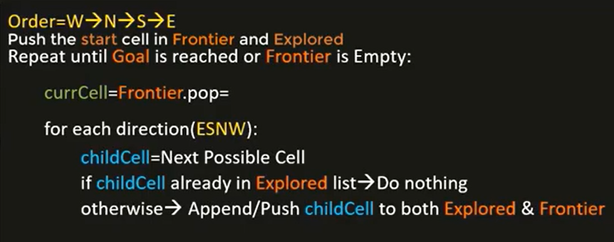

**COMPLETE**

Depth First Search is complete if the tree is finite or else it is not complete (i.e, if the state space graph has cycles).

**OPTIMAL**

Depth First Search is not optimal. It only finds the leftmost solution in the search tree regardless of the depth or cost of the node.

**Solutions**, path costs and n umbers of nodes expanded for each maze are as follows:

**1- Medium maze**

**Path cost: 116**

**Node expanded: 138**

**Solution:**

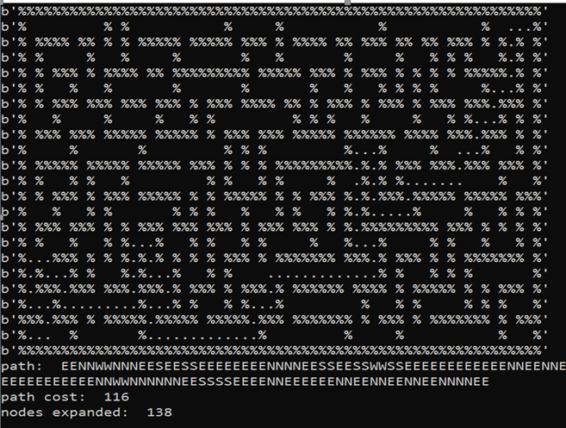

**2- Big maze**

**Path cost: 238**

**Node expanded: 329**

**Solution:**

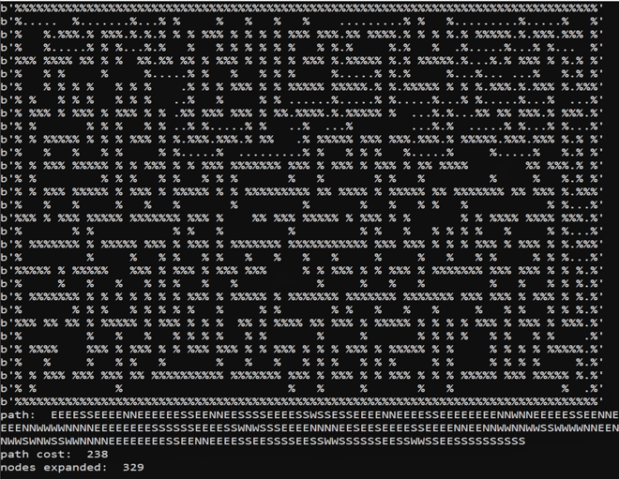

**3- Open Maze**

**Path cost: 238**

**Node expanded: 329**

**Solution:**

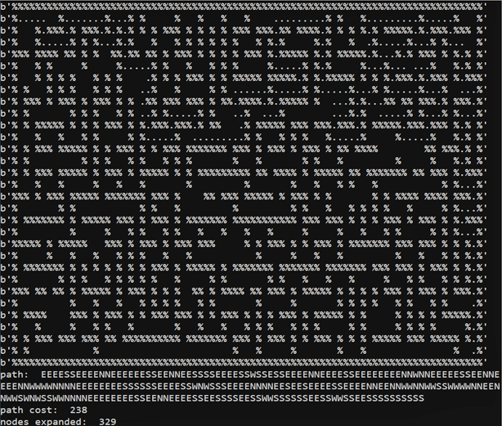

**1-3) Breadth First Search**

"We also used a visited set for repeated state detection." Breadth first search is a level by level search. All the nodes in a particular level are expanded before moving on to the next level. It expands the shallowest node first. It uses a **queue** data structure to maintain a list of all the nodes which have been expanded. The Breadth First Search algorithm applied on pacman in small maze, medium maze and big maze

Pesudo Code

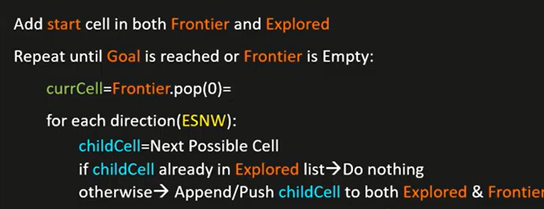

**COMPLETE**

Breadth First Search is complete because if a solution exits then the tree is finite.

**OPT IMAL**

Breadth First Search is optimal only if the cost of all the arcs in the state space graph is the same.

**Solutions**, path costs and n umbers of nodes expanded for each maze are as follows:

**1- Medium maze**

**Path cost: 94**

**Node expanded: 608**

**Solution:**

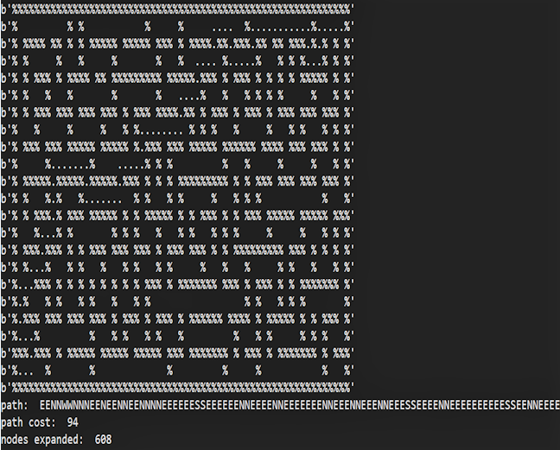

**2- Big maze**

**Path cost: 148**

**Node expanded: 1255**

**Solution:**

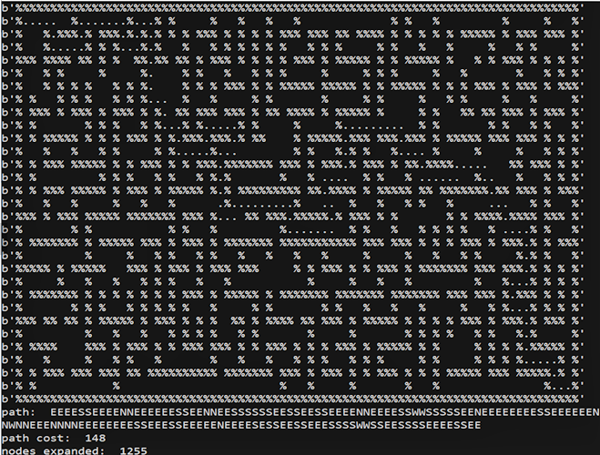

**3- Open Maze**

**Path cost: 45**

**Node expanded: 527**

**Solution:**

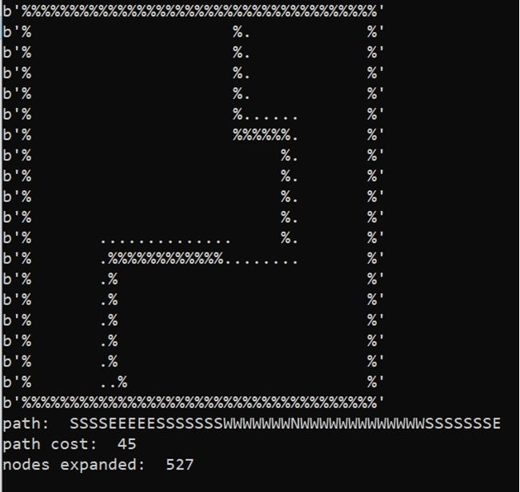

**1-4) Greedy Best First search**

"we also used a visited set for repeated state detection". Gready search falls under the category of informed search strategy. The difference between the BFS is that we use the priority queue structure (manhattan distance as the key)to store the frontier nodes.

**COMPLETE**

Gready Search is not complete is finite.

**OPT IMAL**

Gready Search is not optimal

**Solutions**, path costs and n umbers of nodes expanded for each maze are as follows:

**1- Meduim Maze**

**Path cost: 94**

**Node expanded:103**

**Solution:**

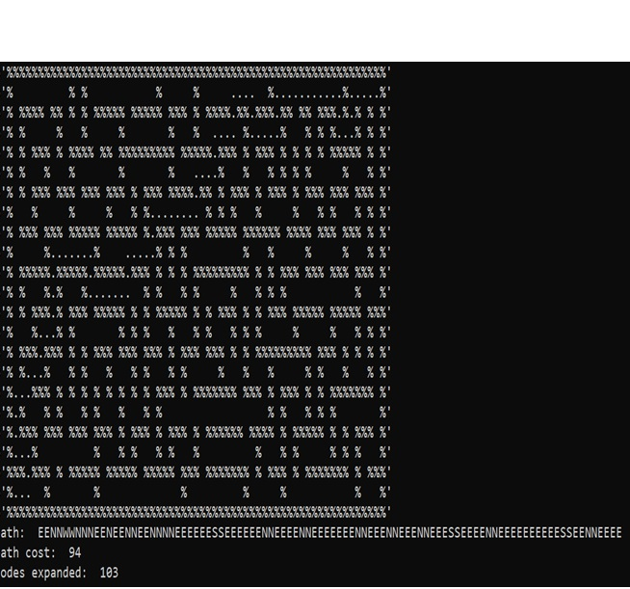

**2- Big Maze**

**Path cost: 222**

**Node expanded: 290**

**Solution:** 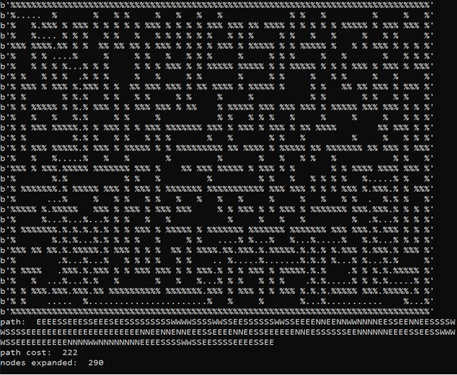

**3- Open Maze**

**Path cost: 57**

**Node expanded: 155**

**Solution:**

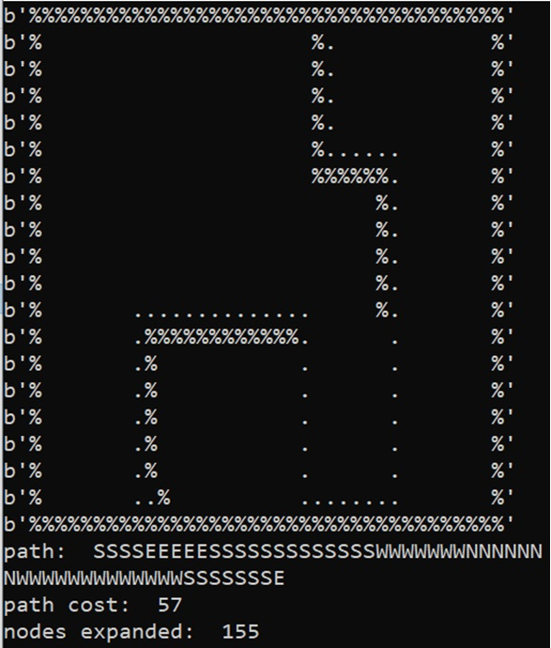

**1-5) A* Search**

A* search falls under the category of informed search strategy. This kind of search is also called best first search. A* search evaluates which node to combine using g(n) i.e, the cost to reach the node and h(n) i.e, the cost to get from the current node to the goal node, represented as :

f(n) = g(n) + h(n) The A* Search algorithm applied on pacman in small maze, medium maze and big maze.

**COMPLETE**

A* search is complete.

**OPT IMAL**

A* search is optimal.

Pesudo Code

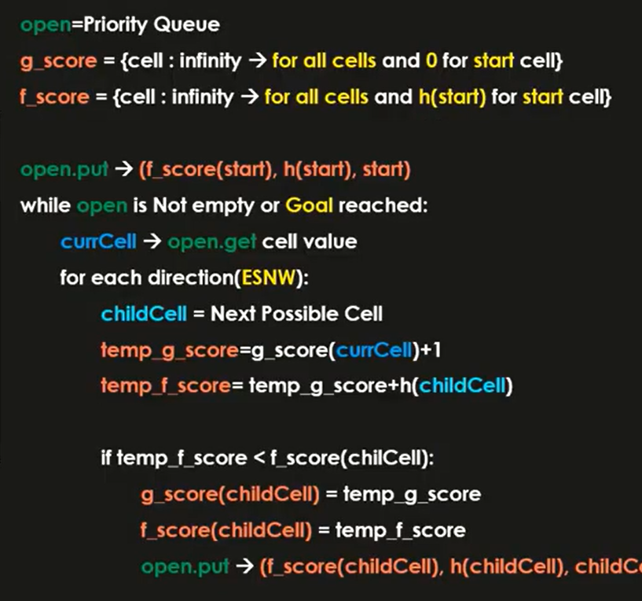

**Solutions**, path costs and n umbers of nodes expanded for each maze are as follows:

**1- Meduim Maze**

**Path cost: 94**

**Node expanded:335**

**Solution:** 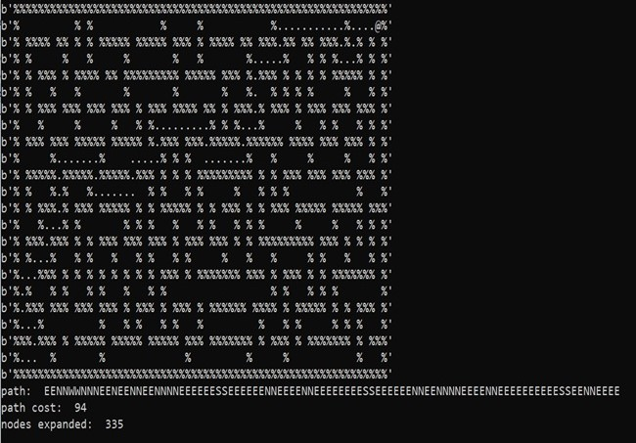

**2- Big Maze**

**Path cost: 148**

**Node expanded: 1113**

**Solution:**

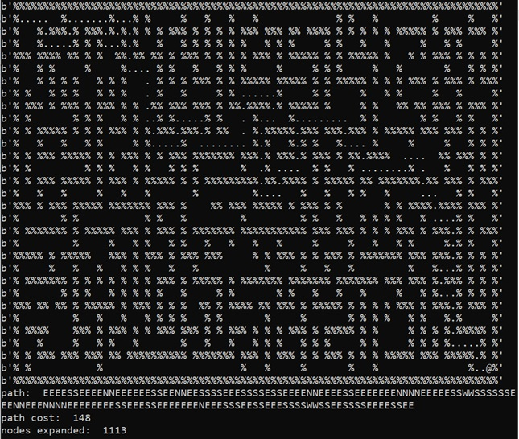

**3- Open Maze**

**Path cost: 148**

**Node expanded: 1113**

**Solution:**

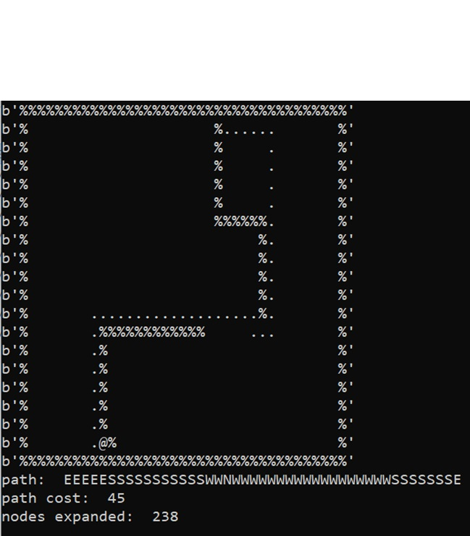

**1-6) Conclusion of Search with Single dot (goal):**

**The path costs and n umbers of nodes expanded for each algorithm on each maze is summarized**

|  |  |  |  |  |  |  |
| --- | --- | --- | --- | --- | --- | --- |
|  | Path cost | | | Expanded nodes | | |
|  | medium | big | open | medium | big | open |
| DFS | 116 | 238 | 238 | 138 | 329 | 329 |
| BFS | 94 | 148 | 45 | 608 | 1255 | 527 |
| Greedy | 94 | 222 | 57 | 103 | 290 | 155 |
| A* | 94 | 148 | 148 | 335 | 1113 | 1113 |

**From this table we can see that:**

1. **In medium Maze**: Best Search Algorithm is (Gready), however both BFS, GREEDY and A* have the same Path Cost but Gready Search used the least Expanded nodes**.**
2. **In Big Maze**: Best Search Algorithm is (A*), however both BFS and A* have the same Path Cost but A* Search used the least Expanded nodes**.**
3. **In Open Maze**: Best Search Algorithm is (BFS), because BFS search take the least Path Cost**.**

**2- Search with multiple dots(goals):**

**-- Using A* Search Algorithm:**

**1- Tiny search**

**Path cost: 7**

**Node expanded: 10**

**Solution:**

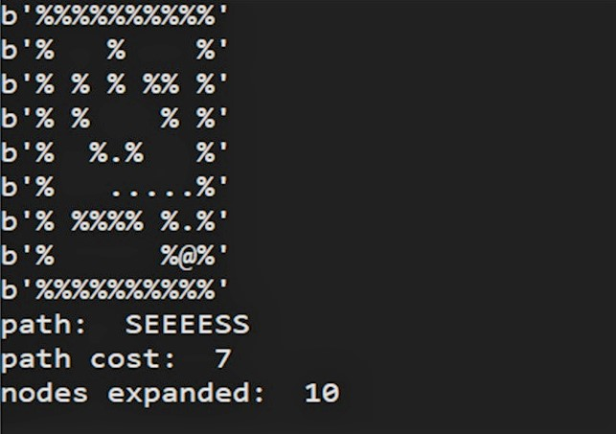

**2- Small search**

**Path cost: 165**

**Node expanded: 332**

**Solution:**

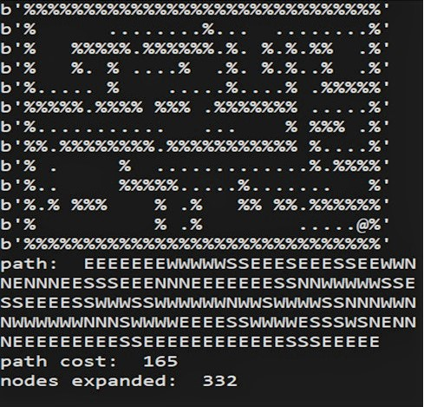

**3- Medium search**

**Path cost: 256**

**Node expanded: 591**

**Solution:**

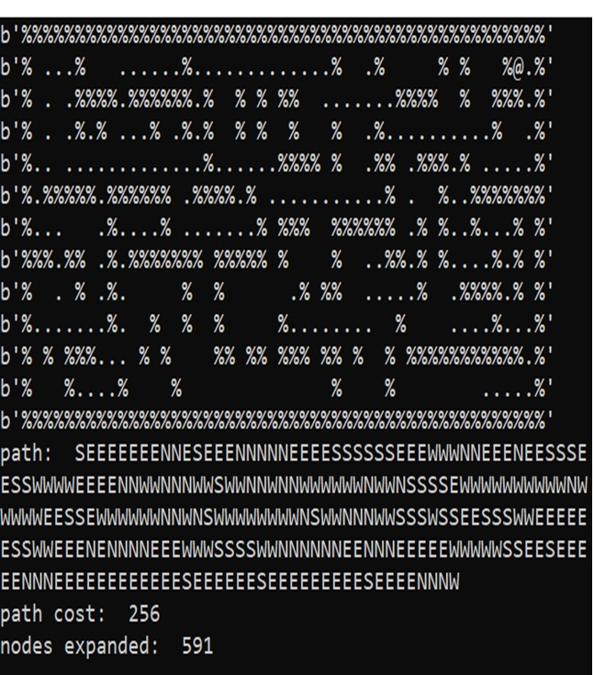

**-- Using BFS Algorithm:**

**Tiny search**

**Path cost: 7**

**Node expanded: 38**

**Solution:**

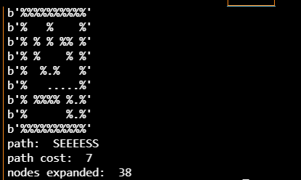

**Small search**

**Path cost: 167**

**Node expanded: 672**

**Solution:**

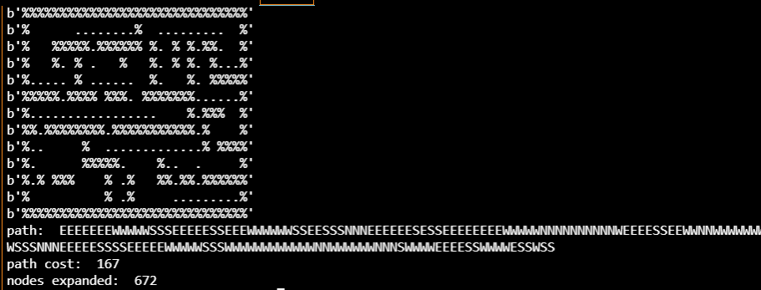

**Medium search**

**Path cost: 246**

**Node expanded: 1195**

**Solution:**

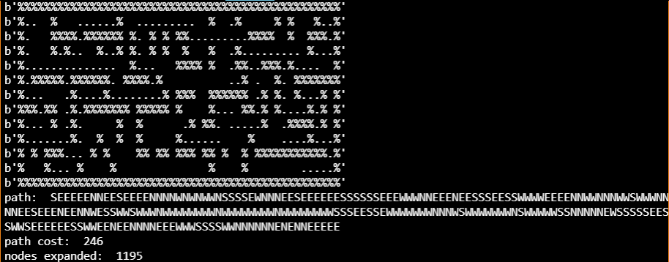

**-- Conclusion of Search with Single dot (goal):**

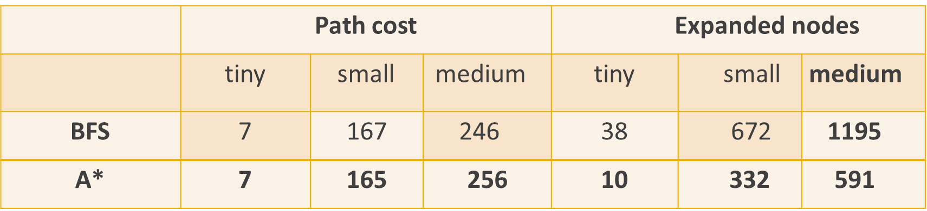

**From this table we can see that:**

1. **In small search** : Best Search Algorithm is (A*), because A* search take the least Path Cost**.**
2. **In tiny search** : Best Search Algorithm is (A*), however both BFS and A* have the same Path Cost but A* Search used the least Expanded nodes**.**
3. **In Medium Maze**: Best Search Algorithm is (BFS), because BFS search take the least Path Cost**.**